Title: Secure Multi-Department Network Design & Analysis
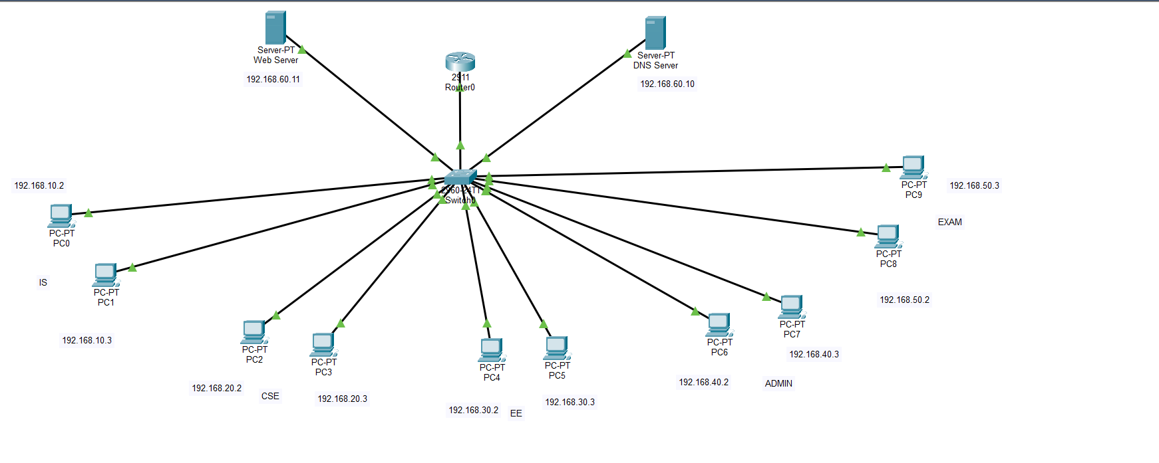
- This is my simple topology which has 5 departments (IS, CSE, EE, ADMIN, EXAM) .
- First of all I made VLANS using GUI but I will show which commands can we use if we want to make them in CLI.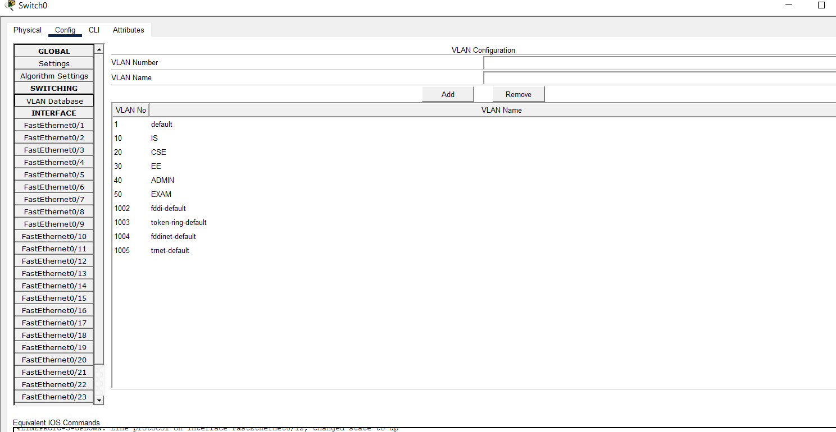

- This is the GUI interface. I assigned VLAN 10 to IS etc.
These are the CLI commands we can use :
Switch(config)#
Switch(config)#vlan 60
Switch(config-vlan)# name abcd
Switch(config-vlan)#
And to remove a VLAN we can use :
Switch(config-vlan)#no vlan 60
Switch(config)#

- After that I assigned the PCs that which PC belongs to which VLAN and for every VLAN I designated 2 PCs. Through this window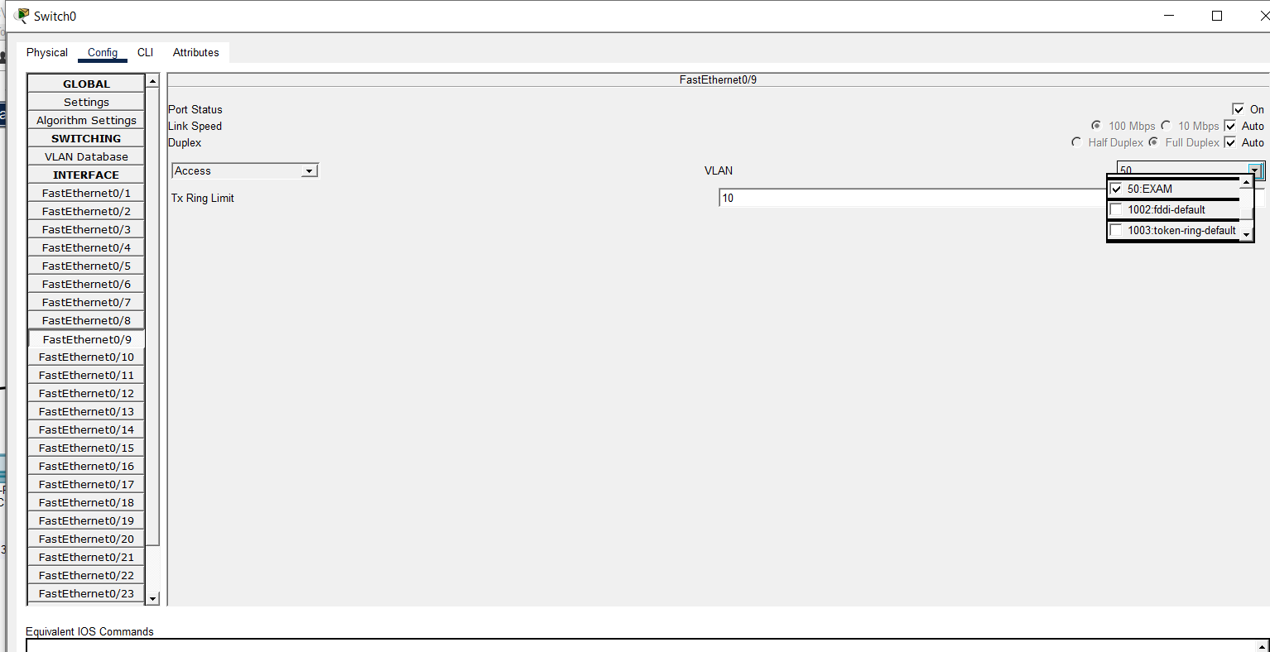

- We can also use CLI commands for this purpose by assigning port numbers to the respected VLANs:;

Switch(config)# interface range fa0/1-2
Switch(config-if-range)# switchport mode access
Switch(config-if-range)# switchport access vlan 10
Switch(config-if-range)# exit
- After that I enabled Inter- VLAN routing by first enabling a special port known as trunk port (It’s purpose is to pass out the intended data to the specific department rather than the whole network). I enabled it by going to that port which is directly connected to the router and making it trunk port.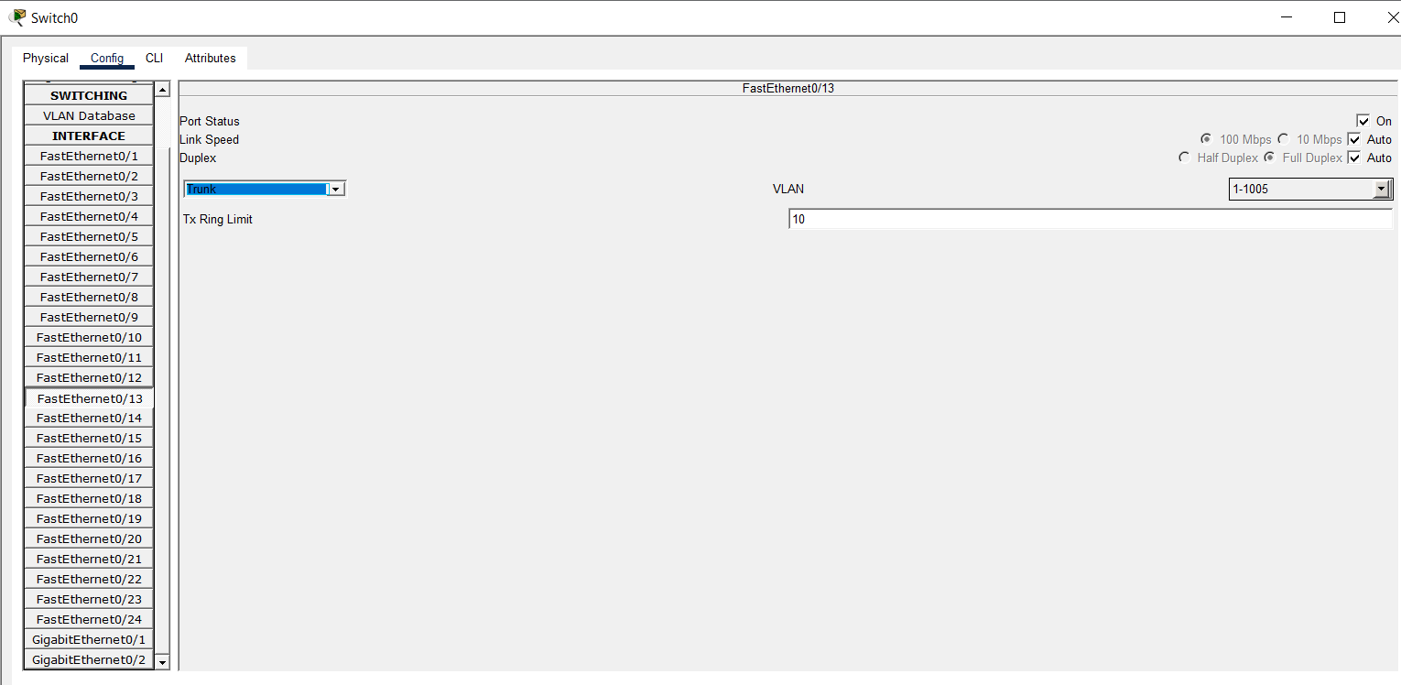

- The respective CLI commands will be :

Switch(config)#interface FastEthernet0/13
Switch(config-if)#
Switch(config-if)#switchport mode access
Switch(config-if)#
Switch(config-if)#switchport mode trunk

Switch(config-if)#

- This isn’t the end now It was the first step we took now we need to create Virtual doors for each VLAN. We cannot do it by using GUI so we have to rely completely on CLI using the following commands:

Router(config)# interface gig0/0.10
Router(config-subif)# encapsulation dot1Q 10
Router(config-subif)# ip address 192.168.10.1 255.255.255.0
Router(config-subif)# exit

This is for 1 department we will have to do it for every department but with some minor change.
- Now we can communicate with every department.
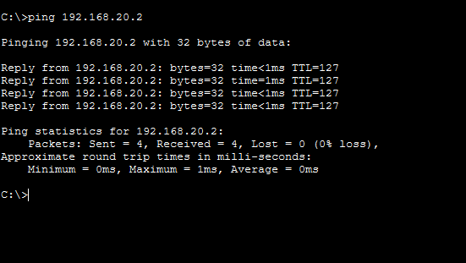

- After that it’s time to enable DHCP service to assign IPs to every PC. By using either a DNS server and using it’s GUI terminal or we can just configure it on the router using CLI bu using the following commands

:Router(config)# ip dhcp pool IS_POOL
Router(config-dhcp)# network 192.168.10.0 255.255.255.0
Router(config-dhcp)# default-router 192.168.10.1
Router(config-dhcp)# dns-server 192.168.60.10 ( DNS Server IP here)
Router(config-dhcp)# exit

We have to do this for every department.After doing this we can go to every PC and instead of static we enable DHCP and it would automatically fill up.
- After that I configured the DNS and WEB server.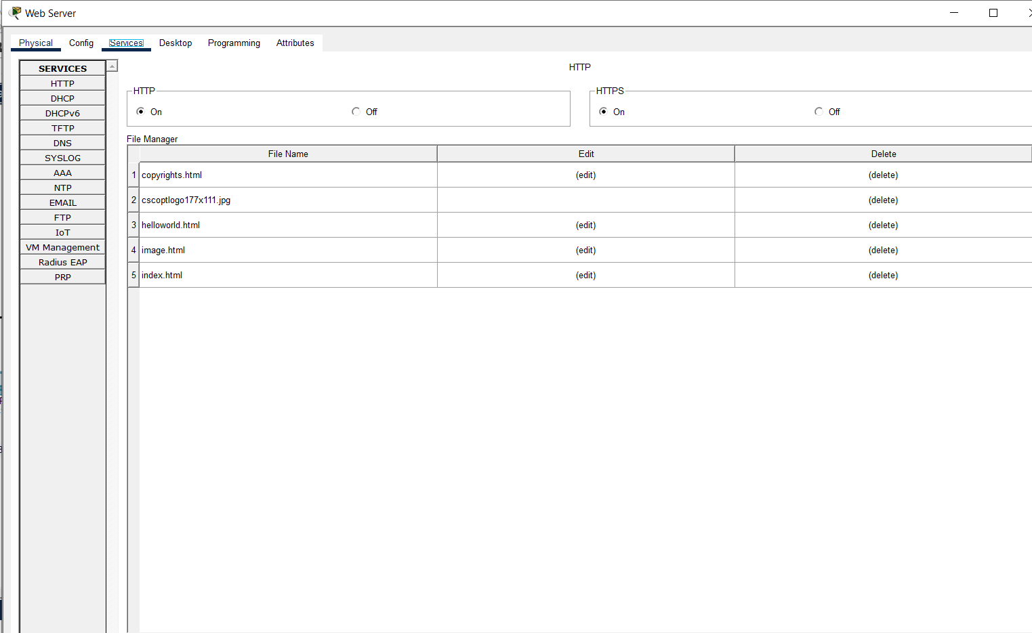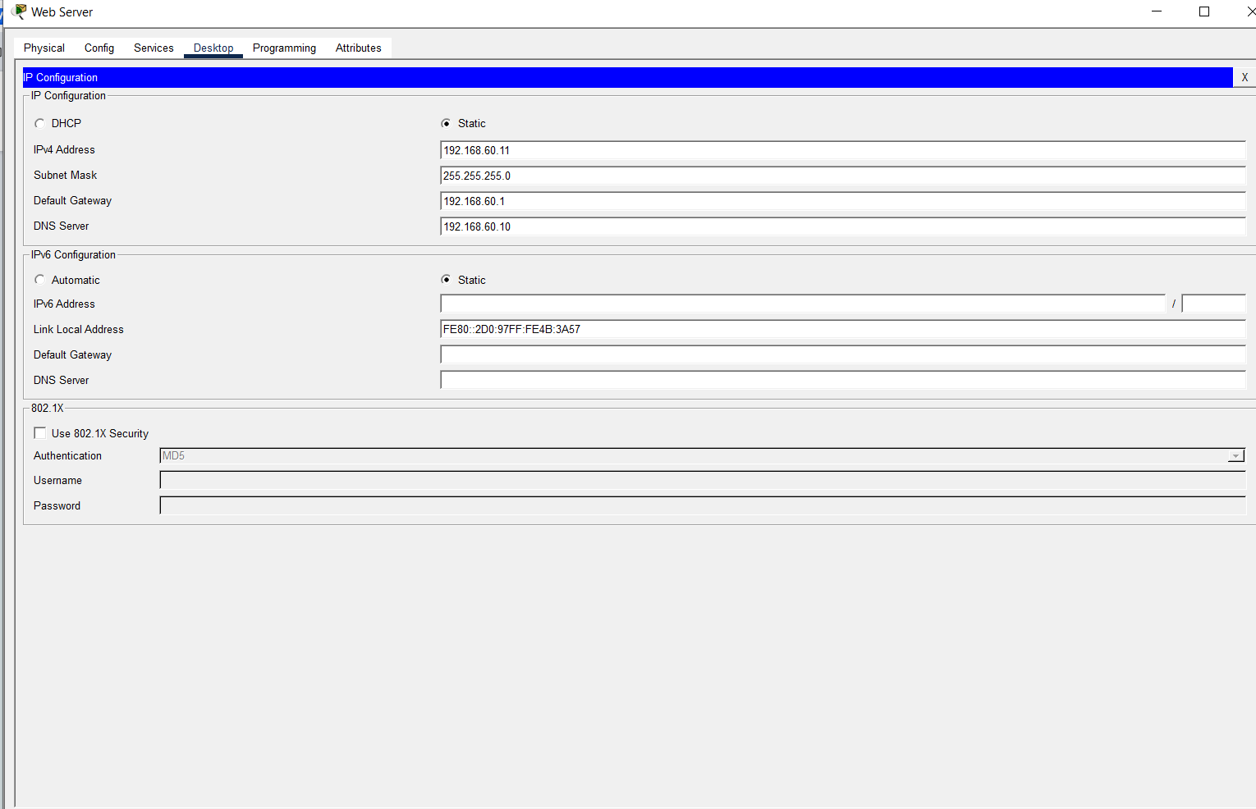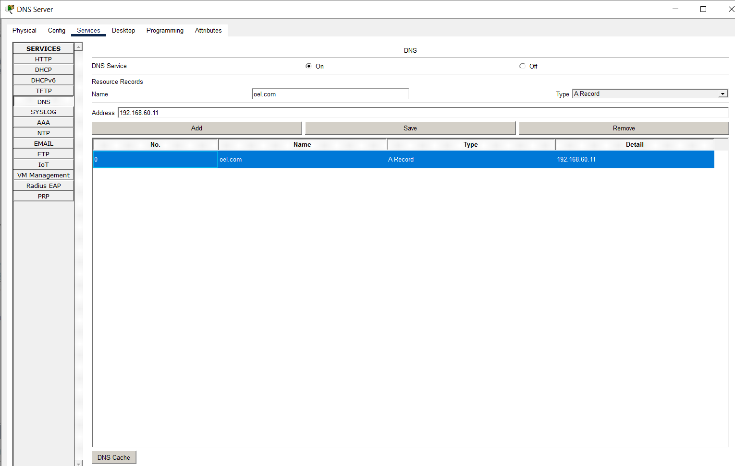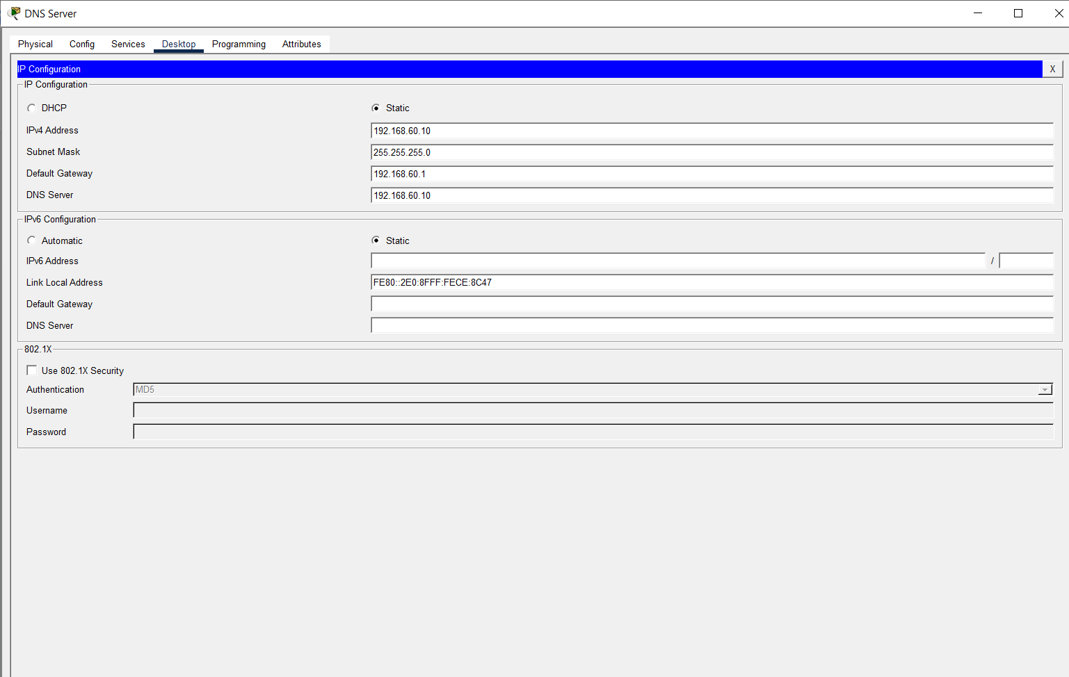

- And to verify the working I went to a PC and opened the web browser and typed the IP of web server and got the reply.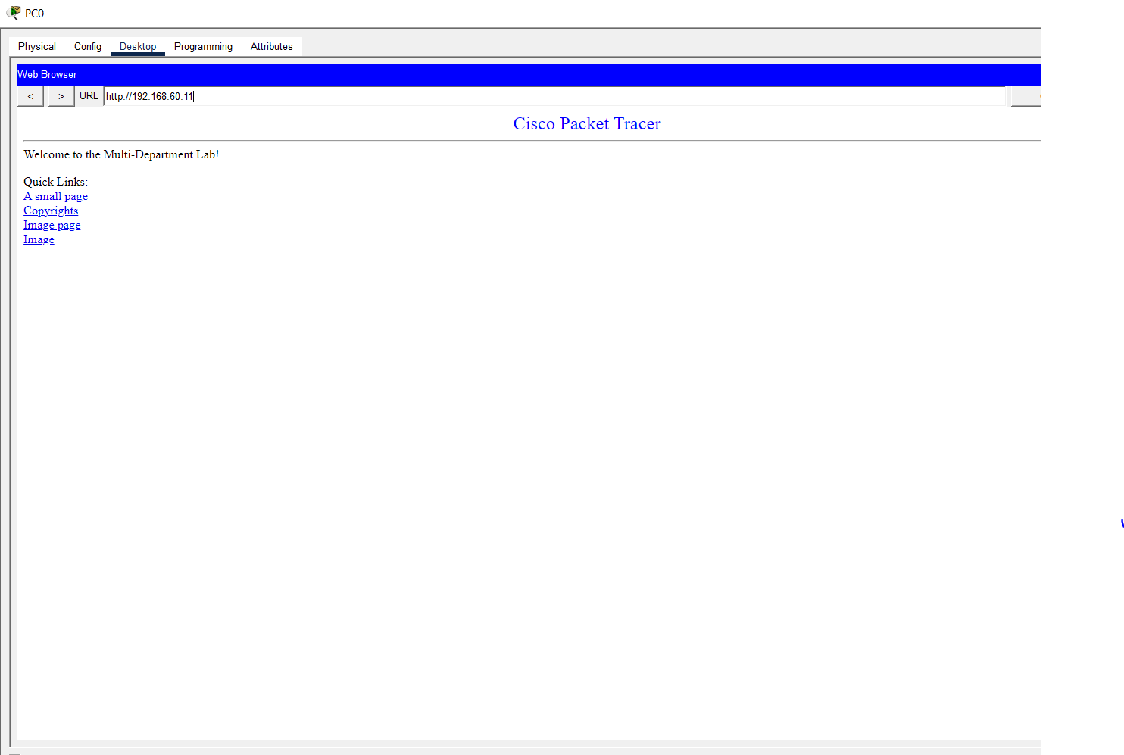

- Security Tasks:
- Apply ACL s
Router(config)# access-list 101 deny ip 192.168.30.0 0.0.0.255 192.168.40.0 0.0.0.255
Router(config)# access-list 101 permit ip any any
Router(config)# interface gig0/0.30
Router(config-subif)# ip access-group 101 in

- Restrict inter-department access

- Basic router hardening
Router> enable
Router# configure terminal
Router(config)# line console 0
Router(config-line)# password MySecretCon123
Router(config-line)# login
Router(config-line)# exit

